**Linux Slave Server adding to jenkins nodes:**

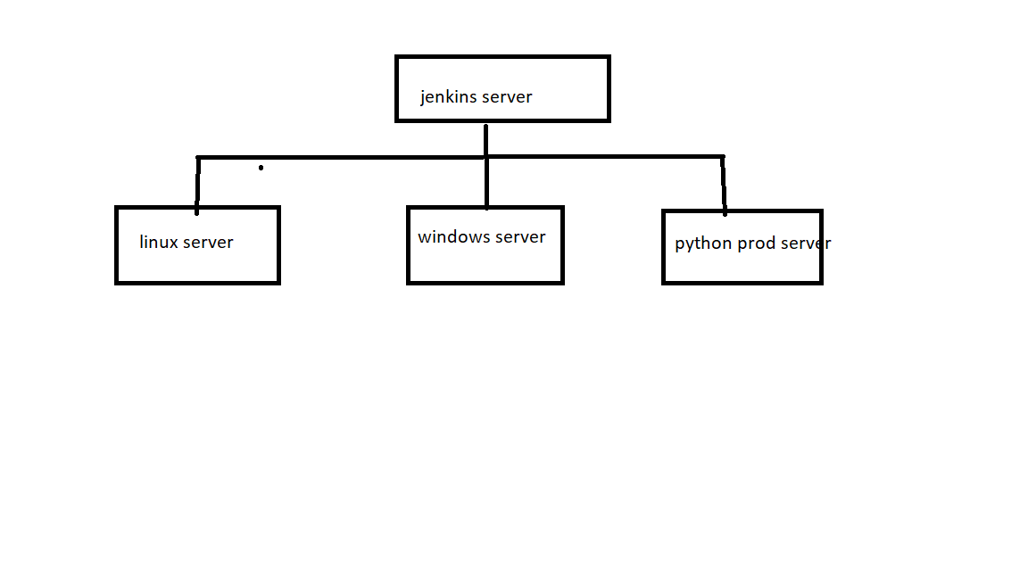

**STEP1:** Open the jenkins server and switch to the Jenkins user in jenkins server

[root] su – jenkins

[jenkins]

Generate private and public keys here by using ssh-keygen

[jenkins]ssh-keygen –t rsa

Type enter, enter , enter

[]ls –a

[]cd .ssh

[jenkins .ssh] ls

**Id_rsa**  **Ida_rsa.pub**

**Copy the public_key and open the slave server (prod server)**

**[prod srvr] apt update**

**[prod srvr] sudo apt-get install fontconfig openjdk-11-jre**

**[prod_server] useradd –m jenkins**

**[]passwd jenkins**

**[]su – jenkins**

**$ bash**

**[jenkins]ssh-keygen –t rsa**

**Enter enter enter**

**[jenk]cd .ssh**

**[jenkins] id_rsa id_rsa.pub**

**[jenkins] rm id_rsa id_rsa.pub**

**Remove this two keys because we don’t require**

**Create file named authorized_keys in this .ssh folder and paste public key code of jenkins server (.ssh folder public key).**

**[jenkins] vi authorized_keys**

**113bjb31nbn3b1nb3kjnb1jb1nk133jkjnb3kjb1**

**:wq!**

**Now go to jenkins server to check connection of prod server.**

**[jenkins server] ssh** [**jenkins@1.2.3.4**](mailto:jenkins@1.2.3.4) **->prod server private I/p**

Type yes ...

[jenkins prod] ---> sucessfully accessed prod server from jenkins server to prod svrv

$

Exit

Now open Jenkins dashboard:

**Go to manage jenkins**

**Select manage nodes**

**Give name to node: Screenate prod node**

**Description : prod server joining**

**No.of exec 1**

**Remoteroot: /home/jenkins**

**Labels : Screenateprod**

**Usage : only build with label expression matching this node.**

**Launch mode : Launch via SSH**

**HOST: 1.2.3.4 -> slave private I/p**

**ADD Credentails:-**

**Sel SSH and private key**

**Uname : jenkins**

**Privatekey:**

**Paste private key of the jenkins server .ssh id_rsa**

**Save**

**Select jenkins credentials : jenkins (which we gave now)**

**Save**

**Or else don’t do ssh jenk@pvtip go with process one upto pub shhkey pasting to slave auth_keys and in jenk slaves go with manually trust keys instead of going with knows hosts.**

**Slave added successfully.**

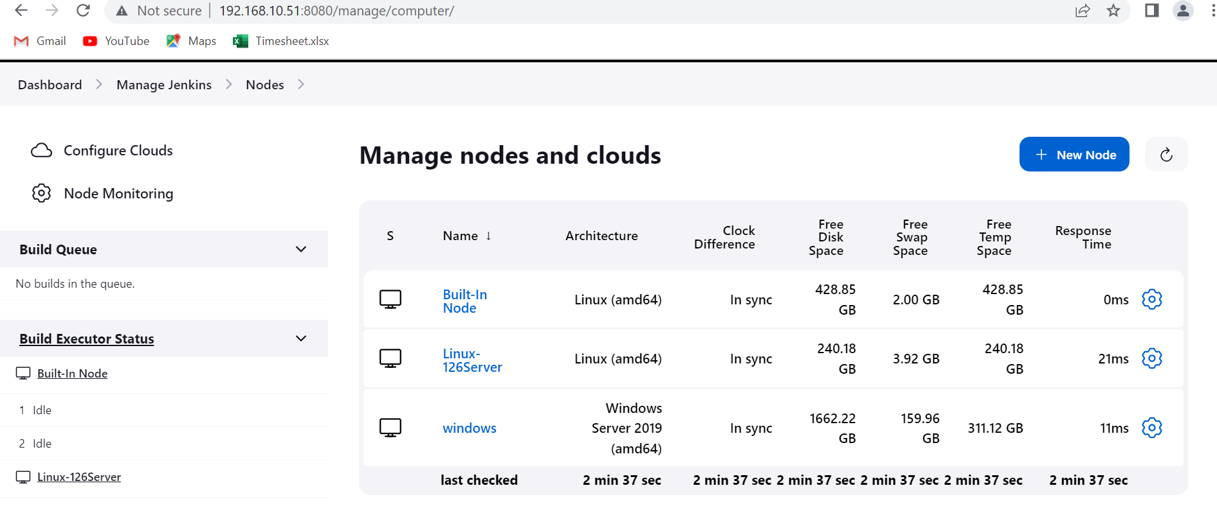

**Now build the using pipeline code and mention slave label name in pipeline**

**It will get sucessful..**

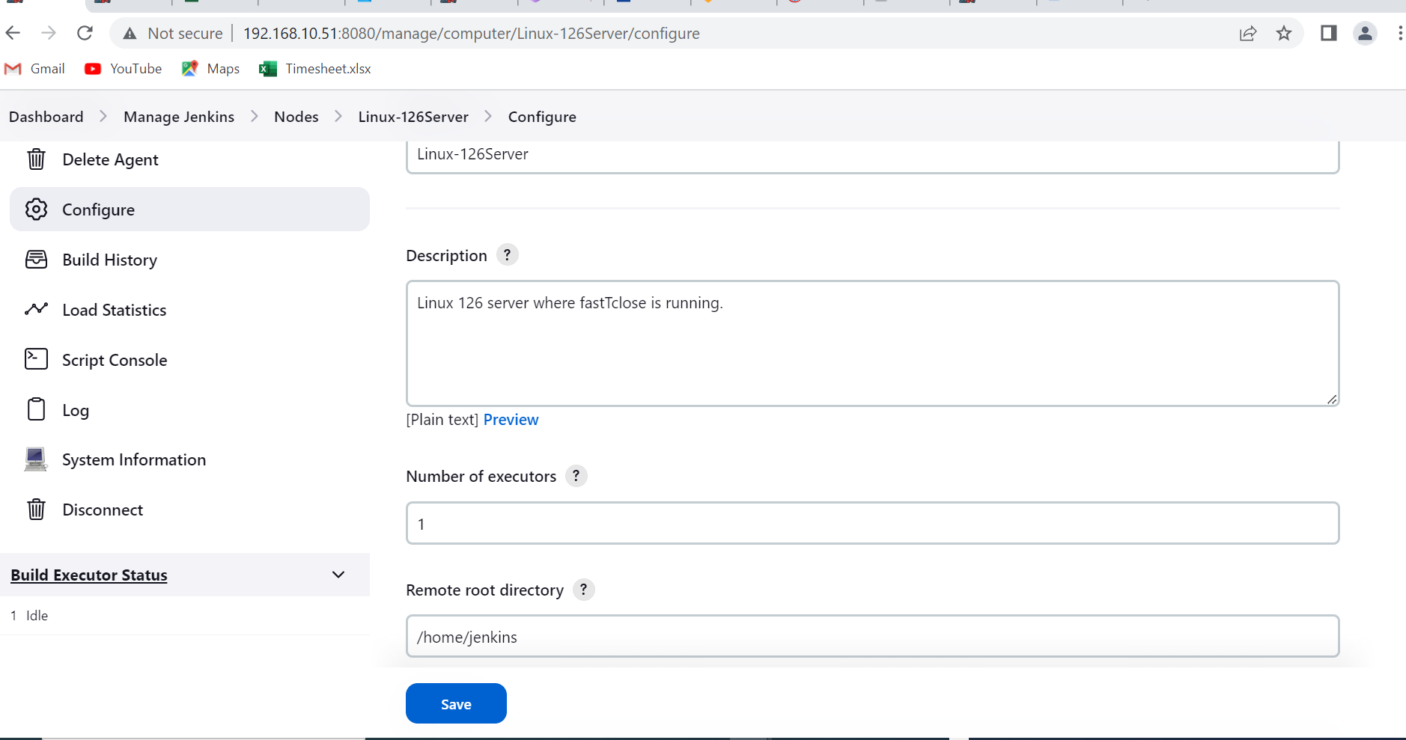

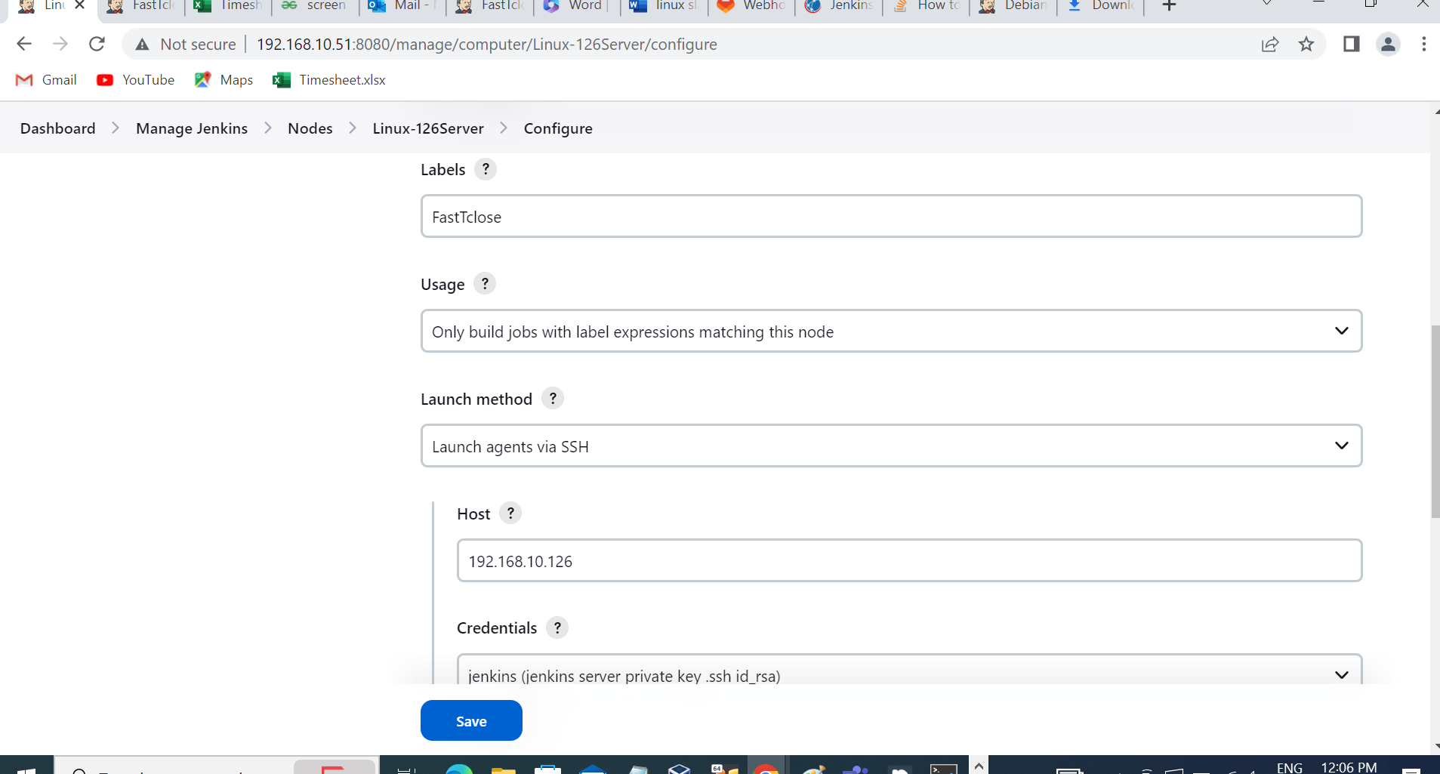

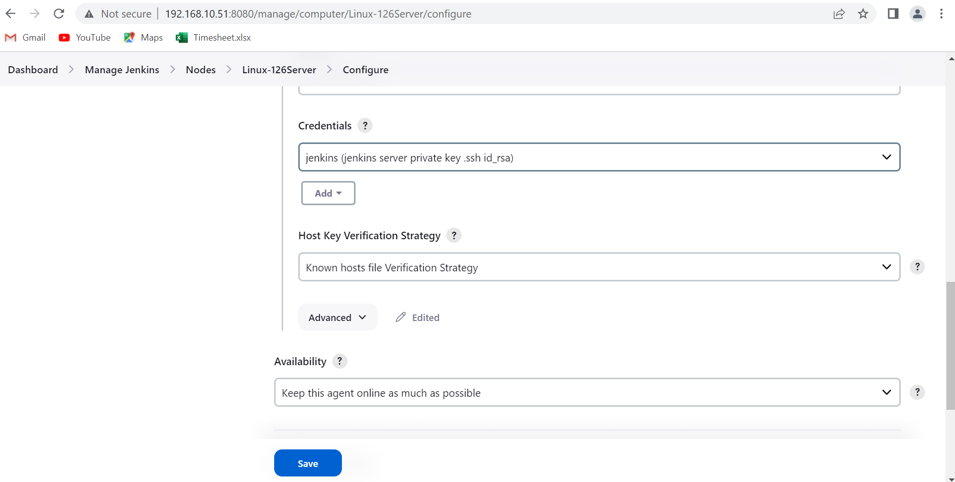

**pipeline {**

**agent {label 'FastTclose'}**

**stages {**

**stage('Git checkout') {**

**steps {**

**git branch: 'master', credentialsId: 'PAT', url: 'https://proj.git'**

**}**

**}**

**}**

**post{**

**failure{**

**mail to: "nadimpali.pradeepk@.com",**

**subject: "jenkins build:${currentBuild.currentResult}: ${env.JOB_NAME}",**

**body: "${currentBuild.currentResult}: Job ${env.JOB_NAME}\nMore Info can be found here: ${env.BUILD_URL}"**

**}**

**}**

**}**

**Process 2:**

If SSH port changed to another port and if face host key verification failed.

Login Linux slave server switch to jenkins user and remove .ssh if there and generate the SSH keys

[jenkins_slave] ssh-keygen –t rsa

Enter

Enter

Enter

[/.ssh]ls

Id_rsa id_rsa.pub

Create the file called authorized_keys

And copy the pubkey of slave ssh to authorized_keys

Vi authorized_keys

Fdggee21ewfewf ewew ew few f ewf ewgf reg reg reg reg reg re grere r324 r432 r43 43 32 432 4 32432 43 t45 gtr4 g r4vr4 tr4g rg reg reg eg eg e gfe gfr gfr gfe g ff df fds fds gfd hre fd ge gfd geg dgdg dsf dsgf s

**Come to jenkins manage nodes:**

**Select add new node and give name to node.**

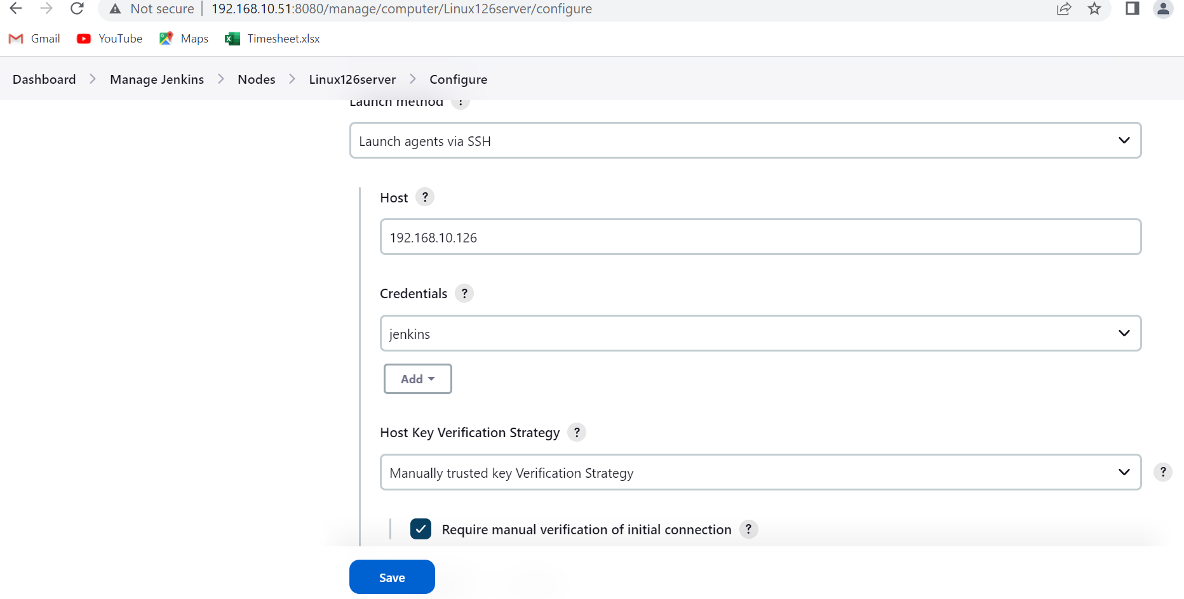

**Give name and description and select launch mode via SSH**

**Host : pvt ip of slave**

**Credentials: sel ssh and pvtkey ,create and select uname jenkins and private key (paste slave ssh private I/p)**

**Select: jenkins cred which we provided above and**

**Select hostkey verification strategy : manually trusted key vrfcn strategy**

**Selct Check req manual vrfctn cnnctn.**

**Change port if ssh port is changed remove 22 and give ssh new port.**

**Save and select right side trust hostkey and slave will automatically connected.**

"Host key verification failed" means that the **host** key of the remote host was changed.

SSH stores the host keys of the remote hosts in ~/.ssh/known_hosts. You can either edit that text file manually and remove the old key (you can see the line number in the error message), or use

ssh-keygen -R hostname

It removes keyhosts file from .ssh folder and we will generate it again with new keys.

Process 3:

Error :

07/15/23 14:05:32] [SSH] SSH host key matches key seen previously for this host. Connection will be allowed. ERROR: Server rejected the 1 private key(s) for jenkins (credentialId:jenkins/method:publickey) [07/15/23 14:05:32] [SSH] Authentication failed. Authentication failed.

**Answer:**

**Follow first process copy id_rsa pub of master jenk to slave ssh authorized_keys and generate the known hosts in jenkins .ssh**   
  
  
**in configure node linux**   
**add name and desc and label and all and Launch method sel ssh**

**Add credentials as uname jenkins and passwd of jenk user in 126 server.**

**Sel manually trusted key check mark require manual verification.**  
**and Launch the node again.**

**Process 4 :**

**[] Create ssh key for both server and copy the public key of jenkins server to slave server**

**[] in node configure credentials paste privete key of jenkins server by selecting ssh pvtkey.**

**[] in host key verification strategy select manually trusted key verification and select require manual verification**

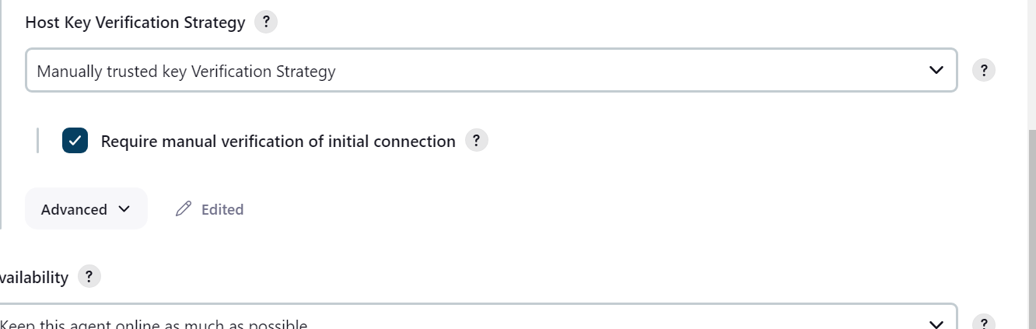

**[] after launching, click launched server select trust manually and select yes**